SCUBA-2 Block Specification
Asynchronous Transmitter

Table of Contents

1. Block Overview 3
1.1 Block Location and Block Interface Within System 3
1.2 Block Functionality / Features 3
1.3 Block Dataflow 3
2. Block Interfaces 4
2.1 Interface Signal Description 4
2.2 Interface Protocol and Timing 4
3. Files of the Block 5
3.1 Source Code 5
3.1.1 us_timer.vhd 5
3.2 Header Code 5
3.2.1 general_pack.vhd 5

Block Overview

Block Location and Block Interface Within System
The asynchronous transmitter serializes data so it may be used to transmit data serially. For a complete description of how the data is transmitted, please see the asynchronous communication technote.

Block Functionality / Features
- Asynchronous reset
- Busy flag output

Block Dataflow
tx_o
Note that rst_i, the reset signal, isn’t shown but is required for proper operation
clk_i
Shift register
Period Counter
busy_o
load
dat_i
Wishbone
Interface
we_i
stb_i
cyc_i
ack_o
enable
reset

Block Interfaces

Interface Signal Description
- Interface Signals
Signal | Description | Direction
Global Signals
clk_i | 25Mhz global clock signal. | In
rst_i | Reset input | In
dat_i | Wishbone data input | Out
we_i | Wishbone write enable | In
stb_i | Wishbone strobe input | In
ack_o | Wishbone acknowledge output | Out
cyc_i | Wishbone cycle input | In
Asynchronous Transmitter Signals
tx_o | Serialized transmitter output pin | Out
busy_o | Transmitter busy flag | Out

Interface Protocol and Timing
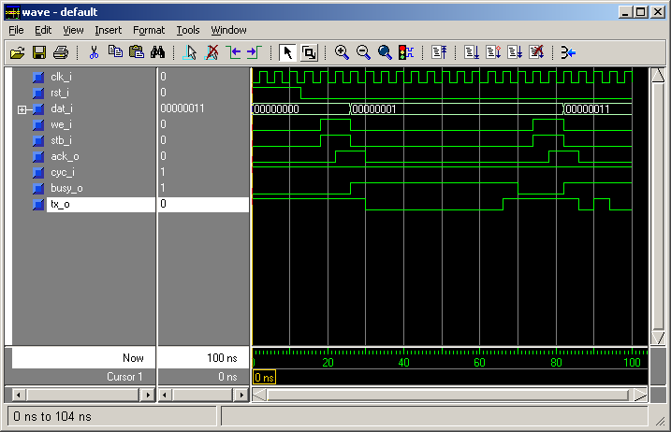
The following figure shows the timing relative to the clk_i signal.

Files of the Block

Source Code

async_tx.vhd

Header Code

async_pack.vhd

